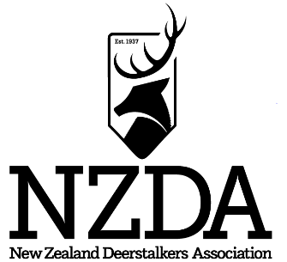

DOUGLAS SCORE TRAINING SEMINAR
HOSTED BY AUCKLAND BRANCH

A Douglas Score training seminar is being planned to take place:
AT: Auckland Branch Clubrooms - 7 Target Street

DATE: 2nd September 2023

The course would be:

Level 1 Certificate Introductory course to Douglas Score system
- Understanding Douglas Score measuring principles
- Attendance at a training school

Level 2 Certificate Training Courses – Revision of Douglas Score system
- Understanding of Douglas Score measuring principles
- Attendance at a training school
- Participating in branch measuring competitions

At the completion of this course participants will have obtained their applicable standard and be eligible for a Douglas Score Practicing Certificate.

A prerequisite of the course is that all participants will have purchased and read a copy of the Douglas Scoring Handbook (available from the national office if you do not already have a copy) AND additional required reading material, which will be forwarded by the national office on registration and the payment of course fee of $30.00.

It is preferable that participants have been actively involved in measuring antler, horn and tusks at a branch level or at least attempted to gain some practical proficiency in measuring antler, horn and tusk heads.

Course participants are required to bring along the following:
- Your Douglas Scoring Handbook and other provided required reading material – see order form
- Measuring tape (in inches). A thin steel tape is ideal. Alternatively a standard width steel tape (in inches) plus a 1200mm long piece of fine copper wire (the core wires of standard phone cable are excellent) or a good fiberglass dress makers measuring tape (in inches) will suffice.
- A pair of small dividers or a small compass.
- A piece of white chalk.
- A calculator, if needed.
- Paper and pen.
- Bring your own food to cover the weekend. Morning and afternoon tea will be provided.
- You may require a sleeping bag.

Please complete and forward to: office@deerstalkers.org.nz and bneville@deerstalkers.co.nz

Yes, I wish to attend the Douglas Score Seminar.
I wish to do Level 1 □ I wish to do Level 2 □ Please indicate either Level 1 or Level 2

Please find enclosed: $20.00 Douglas Score handbook – if you don’t already have one
$20.00 Douglas Score measuring tape
$30.00 Course fee – MANDATORY – includes a large file of required reading material
$_______ TOTAL TO PAY

Name: ________________________________________ Address: ___________________________________

_______________________________________________________________________________________________
Email: _________________________________________ Phone: _____________________________________
Bank Account for payment – Westpac – NZDA Assn Inc - 030558 0139562 00 – Please use Douglas Score as a reference
Under the terms of the Privacy Act 1993, I acknowledge that you are retaining my name and club details for the purpose of mailing further information on NZDA, Douglas Score and related matters.

